Vocabulary Support
Instructions: While watching the video, have this sheet in front of you to help you remember all the definitions. After the video is complete, draw your version of the word in the ‘your picture’ box to help you remember the definitions and uses of the word.
Word | Definition | Visual | Your Picture
Punctuation | Question marks, periods and other marks used in writing to help make the meaning clear | ‘ “ . , ! ?
Exclamation Point | Punctuation mark that is used at the end of a sentence that shows strong feelings. | !
Question Mark | Punctuation mark that is used at the end of a sentence that asks a question. | ?
Period | A punctuation mark that is used at the end of a sentence that includes a statement. | .
Expression | The act of making your thoughts or feelings known through the way you speak | 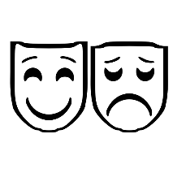
Fluency | The ability to read smoothly and naturally.

